#1 Creating my own function

def my_function():

    print ("Hello")

    print ("Goodbye")

my_function()

#2 making the robot jump

def turn_right():

    turn_left()

    turn_left()

    turn_left()

def jump():

    move()

    turn_left()

    move()

    turn_right()

    move()

    turn_right()

    move()

    turn_left()

for step in range (6):

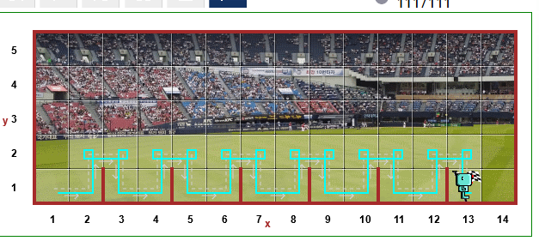    jump()

#3 WHILE loop

def turn_right():

    turn_left()

    turn_left()

    turn_left()

def jump():

    move()

    turn_left()

    move()

    turn_right()

    move()

    turn_right()

    move()

    turn_left()

while not at_goal():

    jump()

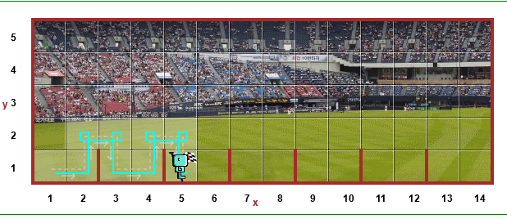

#4 Making the rotor jump when necessary

 def turn_right():

    turn_left()

    turn_left()

    turn_left()

def jump():

    turn_left()

    move()

    turn_right()

    move()

    turn_right()

    move()

    turn_left()

while not at_goal():

    if front_is_clear():

        move()

    elif wall_in_front():

        jump()

1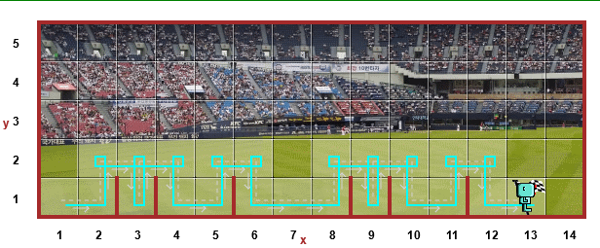

#5 Making the robot run random to the goal

def turn_right():

    turn_left()

    turn_left()

    turn_left()

def go_up():

    while wall_on_right():

        move()

    turn_right()

    move()

    turn_right()

def jump():

    turn_left()

    go_up()

while not at_goal():

    if front_is_clear() and not right_is_clear():

        move()

    elif wall_in_front() and wall_on_right():

        turn_left()

    elif not wall_on_right():

        turn_right()

        move()

        turn_right()

        if front_is_clear():

            move()

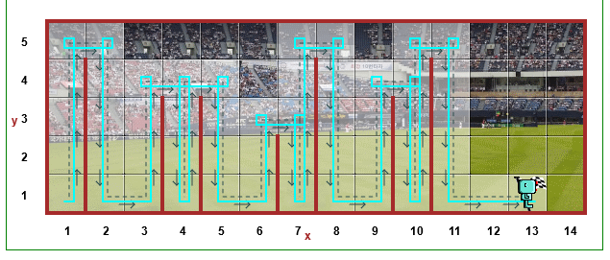

#5 Solucion teacher

def turn_right():

    turn_left()

    turn_left()

    turn_left()

def jump():

    turn_left()

    while wall_on_right():

        move()

    turn_right()

    move()

    turn_right()

    while front_is_clear():

        move()

    turn_left()

while not at_goal():

    if front_is_clear():

        move()

    elif wall_in_front():

        jump()

#6 TEST! taking the robot out of the maze

def turn_right():

    turn_left()

    turn_left()

    turn_left()

while front_is_clear():

    move()

turn_left()

while not at_goal():

    if wall_in_front():

        turn_left()

    if front_is_clear():

        move()

        if right_is_clear():

            turn_right()

